Question 4:

Section 2:

The following functions can be derived from the case study brief:

- Add Trip - User adding a trip to the database
    - Inputs: Trip ID, Start location, destination, departure date, departure time, coach type.
    - Outputs: Trip ID, Start location, destination, departure date, departure time, coach type.
    - Entities: Trip database
- Remove Trip - User removing a trip from the database
    - Inputs: Trip ID
    - Outputs: None
    - Entities: Trip database
- Search for trip - User Searching for a trip with a given key and displaying those trips
    - Inputs: Search key x 5 (departure date, destination etc. Can use up to 5 keys at once)
    - Outputs: Trip ID, Start location, destination, departure date, departure time, total seats, available seats.
    - Entities: Trip database
- Display seating plan - System displaying a seating plan for a given trip
    - Inputs: Trip ID
    - Outputs: Image of seating plan, available seats
    - Entities: Trip database, Coach database
- Book seat - User making a reservation for a seat
    - Inputs: Trip ID, seat number, customer name
    - Outputs: Available seats
    - Entities: Trip database, Coach database
- Place on waiting list - System placing a customer on a waiting list if there are no seats for a trip.
    - Inputs: Customer name, Desired destination, Desired date
    - Outputs: Queue number, Customer name, Desired destination, Desired date
    - Entities: Waiting list database
- Pay deposit - Customer pays the deposit once the seat has been allocated.
    - Inputs: Trip ID, seat number, customer name, amount, account number, sort code, email address.
    - Outputs: Invoice number, Trip ID, seat number, customer name, amount, date.
    - Entities: Trip database, Coach database, Financial database
- Pay total - For account holders customer pays complete bill
    - Inputs: Trip ID, seat number, customer ID (account holder only).
    - Outputs: Invoice number, customer name, amount, date.
    - Entities: Trip database, Coach database, Financial database, Customer accounts database.
- Send invoice - System sends an invoice to a customer
    - Inputs: Invoice number.
    - Outputs: Invoice number, Trip ID, seat number, customer name, amount, date.
    - Entities: Trip database, Coach database, Financial database

- Create finance report - System generates finance report for a given time period
    - Inputs: Start Date, finish date.
    - Outputs: Invoice number, Trip ID, seat number, customer name, amount.
    - Entities: Trip database, Coach database, Financial database
- Backup database - System backs up the database
    - Inputs: Backup number, Trip database, coach database, financial database, customer accounts database, waiting list database.
    - Outputs: Complete system image
    - Entities: Trip database, Coach database, Financial database, customer accounts database, waiting list database.
- Restore database - System restores database from previous backup
    - Inputs: Backup number
    - Outputs: Complete system image restore
    - Entities: Trip database, Coach database, Financial database, customer accounts database.

Considering the above functions we have the following entities which comprise of the following data elements / variables:

- Trip database
  - Trip ID - Unique key for the trip
  - Start location - Start location for the trip
  - Destination - Destination of the drip
  - Departure Date - The date of departure for the trip
  - Departure Time - The time of departure for the trip
  - Coach Type - The type of coach to be allocated to the trip
  - Available seats - The number of seats available.
- Coach Database
  - Coach type - The type of the coach
  - Total Seats - The amount of seats on the bus
- Financial Database
  - Invoice Number - Unique key for the invoice
  - Customer Name - Name of the customer for which the invoice is for.
  - Customer ID (if applicable) - Customer ID if the customer has an account.
  - Seat Number - Seat number that has been booked
  - Amount - The amount associated with the invoice.
  - Date - The date the invoice was created.
- Customer Database
  - Customer name - Name of the customer
  - Customer ID - Unique key for the customer
  - Bank account number - Customers bank account number
  - Bank sort code - Customers bank sort code
  - Email address - Email address for the customer
- Waiting list database
  - Queue number - Place in the queue.
  - Customer Name - Name of the customer .
  - Desired Destination - The destination the customer would like to get to.
  - Desired Date - The date the customer would like to travel.

Calculating the FPC (Function point count):

With the above functions / transactions described we can quantify the complexity of each function as seen below:

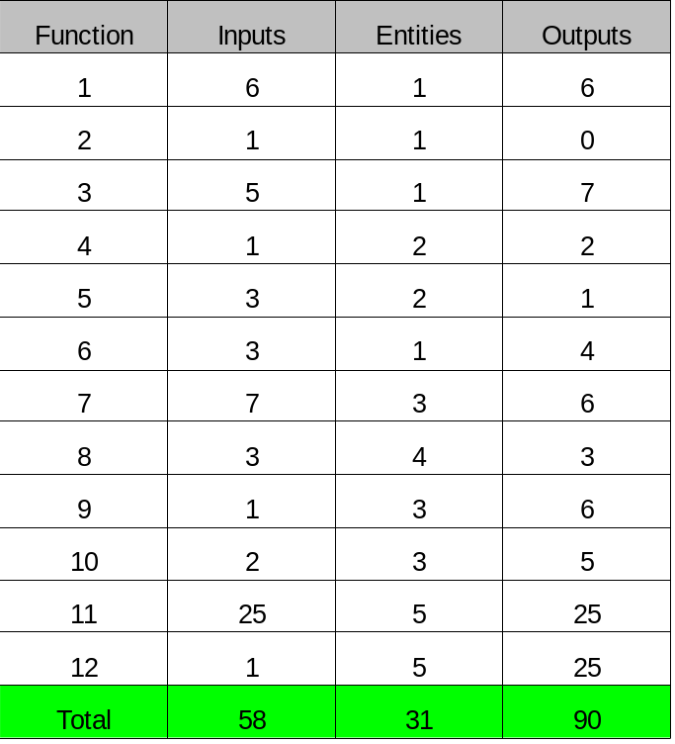

With the above total inputs, entities and outputs we can calculate the FPC:

FPC = Inputs * W1 + Entities * W2 + Outputs * W3

For the weighting constants we will use the industry standards as follows:

W1 = 0.58
W2 = 1.66
W3 = 0.26

So,

FPC = 58*0.58 + 31*1.66 + 90*0.26
FPC = 33.64 + 51.46 + 23.4
FPC = 108.5

Section 3:

With the above functions and given requirement spec I have rated the complexity factors as below from 0 to 5:

- Data communications - 3
  - This is quiet complex as it involves multiple sites and concurrent access to a database.
- Distributed functions - 2
  - This is not so complex. The software should be updated online so if versions of the software are kept up to date the functionality should be identical.
- Performance objectives - 2
  - This is not too great, the main performance objective is to maintain a consistent database. We also have to consider user access performance.
- Heavily used configuration - 1
  - This is a new system so we don't have to deal with a previous configuration but there may be simple data transfer from the old system.
- Transaction rate - 3
  - This really depends on how many users are accessing the system at one time. If the customer base is small this transaction rate will be small. 3 is a pessimistic estimate.
- On-line data entry - 2
  - This will be just simple forms that could for example just write to an SQL database.
- End user efficiency - 2
  - There is nothing too complex here, the only bottle neck would be the connection to the database.
- On-line update - 2
  - As the actual data is kept separate from the software it should be easy to update without compromising the database consistency.
- Installation ease - 3
  - This is slightly complex. As it involves multiple physical locations and multiple systems working together.
- Operational ease - 1
  - The system will be easy to operate. It will just be a simple set of forms for the user and easy to interpret GUI's.
- Multiple sites - 3
  - This system exists over multiple sites.
- Facilitate change - 2
  - Change should be easy enough if the database is designed well, ie, well normalised.
- Interface to systems - 2
  - The system will have an interface to a database, probably SQL.
- Security / privacy - 3
  - This is important and therefore requires extensive attention.
- User training - 1
  - The system will be easy to use.
- Third party use - 0
  - There will be no third party as such, the users are the customers and the company.

The total complexity factor (TCF) is given as the sum of the above:

TCF = 31

With the TCF we can now calculate the adjustment factor (AF):

AF = 0.65 + 0.005 * TCF
= 0.65 + 0.005 * 31
= 0.805

Section 4:

The adjusted function point count (AFPC) is as follows:

AFPC = AF * FPC
= 0.805 * 108.5
= 87.3425

Section 5:

5.1)

To calculate the effort in man days we will be using the 3GL part of the table:

Effort = AFPC / Productivity
= 87.3425 / 0.742
= 117.71 man days

5.2)

We can calculate the delivery rate as follows:

Delivery rate = 0.45 * (AFPC)^½
= 4.206 functions per week

5.3)

We can calculate the total elapsed time as follows:

Elapsed time = AFPC / Delivery rate
= 87.3425 / 4.206
= 20.766 weeks

Section 6:
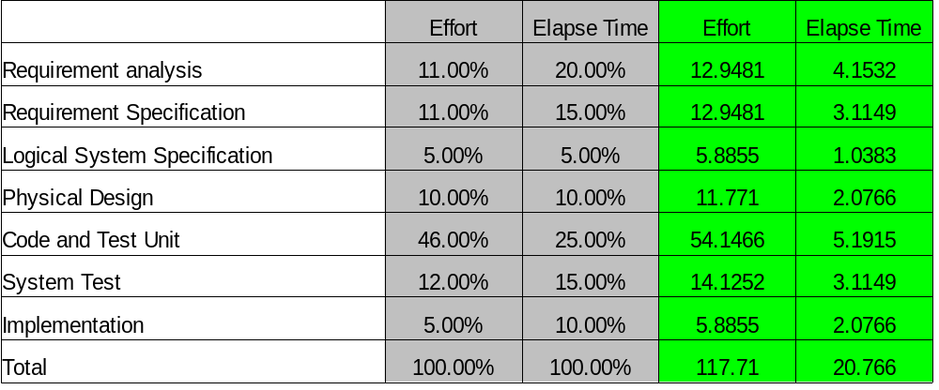
Total effort = 117.71 man days
Total time elapsed = 20.766 weeks

